**Health Class – 7th Grade**

Ms. Andrews [nandi.andrews@henry.k12.ga.us](mailto:nandi.andrews@henry.k12.ga.us) 770-515-7500

## **Course Description:**

The core expectation of the middle school health education program is that students will learn about physical, mental, emotional and social health. It builds students’ knowledge, skills, and positive attitudes about health. The health education program motivates students to improve and maintain their health, prevent disease, and reduce risky behaviors. A planned and sequential 6-8 health education curriculum addresses all dimensions of health in a way that results in students who possess the knowledge and skills to live a healthy life. By providing a comprehensive middle school health education program, we are facilitating optimum student learning. When children are healthy, they can learn; when they are educated, they can stay healthy.

## **Main Goals:**

* Students will gain the knowledge and skills to remain healthy throughout their lives.
* Students will gain an appreciation for the lifelong benefits of living a healthy lifestyle.
* Students will be motivated to improve and maintain their health, prevent disease and injury and reduce risky behaviors.

## **Requirements:**

All students are expected to come to HEALTH EDUCATION CLASS with the following materials:

* Chromebook
* Pencil or pen
* Health notebook
* All health assignments and/or homework

Students will participate in a variety of health education units outlined by the Georgia Health Education Framework. These units include: physical, mental and emotional health, substance use and abuse, injury prevention and safety, family life and relationships, nutrition and physical activity, HIV/AIDS, disease control and prevention, consumer, community and environmental health.

**Individual Class Policies/Procedures:**

Students are encouraged to:

* Always keep a positive attitude!
* Respect themselves, others and the health classroom and all materials
* Demonstrate appropriate behavior at all times.

**Materials:**

* “Choosing the Best Path” Student Manual 3rd edition [www.choosingthebest.org](http://www.choosingthebest.org)
* “Teen Health” Course 2 Glencoe/McGraw-Hill 1999

Following is a tentative schedule for this semester, this can always change based on student progress and school schedule changes.

|  |  |  |
| --- | --- | --- |
| Unit of Study | Standard | Assessment |
| What is Health (Aug. 5 – Sept. 5)   * Health Triangle (Review-Enrich) * Safety * Wellness * Self-Concept * Decision Making | HE7.1, HE7.5, HE7.6 | Decision-Making Scenario Role Playing (quiz grade)Aug. 28 & 29  Chapter Test  Sept. 3 |
| Social, Mental, & Emotional Health  (Sept. 8 – Sept. 25)   * Bullying * Peer Pressure * Conflict Resolution * Friends * Family | HE7.2, HE7.4 | Chapter Test  Sept. 24 & 25 |
| Nutrition (Sept. 26 – Oct.22)   * Nutrients * Food Groups * Healthy Food Choices * Benefits of Exercise * Planning Fitness Goals | HE7.1, HE7.5, HE7.6, HE7.3 | Chapter Test  Oct. 21 & 22 |
| Drugs  (Oct. 23 – Nov 21)   * What are Drugs * Illegal Drugs * Substance Addiction * Choosing to be Drug Free | HE7.1, HE7.7, HE7.8 | Chapter Test  Nov. 20 & 21  Drugs Project |
| Sex Education  *Choosing the Best (parent approval)*  (Dec. 2 – 20)   * Healthy Relationships * Identifying Risk * Abstinence * How to Say No | HE7.1, HE7.4, HE7.7 | Choosing the Best Unit Test  Dec. 18-20 |

**Grading**:

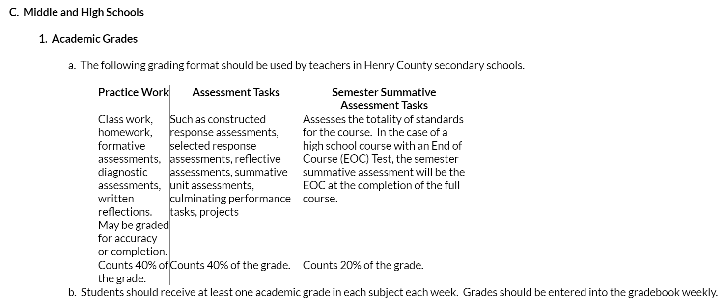

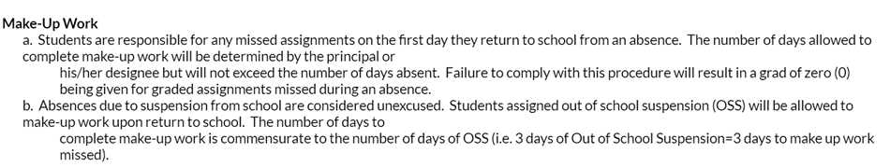

**Late Work Policy:**

|  |  |
| --- | --- |
| 1 day late | - Maximum possible grade 90 |
| 2 days late | - Maximum possible grade 80 |
| 3 days late | - Maximum possible grade 70 |

I have read and understand all of the objectives, requirements, and expectations for this course taught:

Signature ________________________________________ Date ___________________